Exploring Weather Trends

## Observations

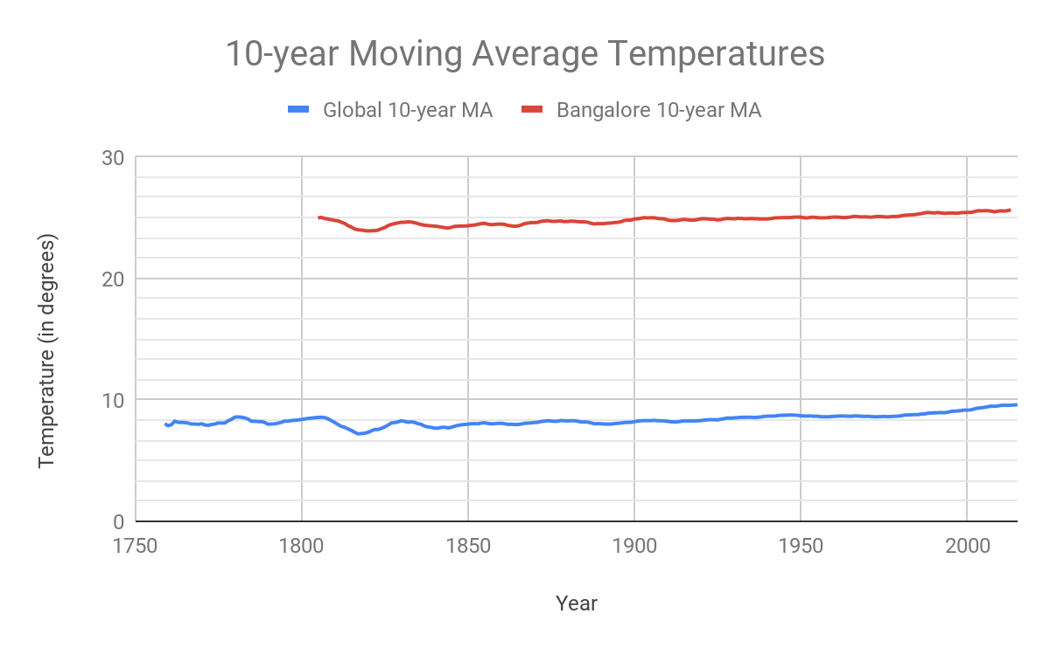

1. We see that Bangalore is on an average much hotter than the global average. Upoon calculating, we see that Bangalore averages 24.85 degrees through all the years vs 8.37 degrees for the global average temperatures.
2. The trend shows that there has been a gradual increase in the average temperatures both globally and for Bangalore over the last ~250 years. Hence the global temperatures are definitely on a rise and this can been seen in my city as well.
3. There isn’t a stark difference between the trends for Global vs Bangalore. Both are rising at about the same rate. Upon calculations from the data, we see that average temperatures in Bangalore rose by 2.12 degrees whereas the global average rose by 1.11 degrees.
4. Similarly calculating difference between overall maximum and minimum recorded temperatures, we see that Bangalore has seen a change of 3.31 degrees, while the global average change is 4.05 degrees.
5. At the very end it looks like the Global trend is on a slightly larger upward rise than Bangalore.
6. We can also observe a slight dip in the average temperatures in the 1810s and this is seen both for Bangalore as well as globally. It would be interesting to understand what global event occurred during this phase.

## Steps Performed

1. Data Extraction using SQL
2. Data Exploration and Cleanup using Google Sheets
3. Data Analysis using Google Sheets

### Data Extraction

1. Checked for the list of Indian cities in the *city_list* table.

SELECT * FROM city_list

WHERE country = ‘India’

Since ‘Bangalore’ is there is in the list, we’ll extract its data from *city_data* table

1. Extracting weather data for Bangalore

SELECT avg_temp, year

FROM city_data

WHERE city = 'Bangalore'

Downloaded the csv of 218 records that resulted from the above query

1. Get all the data from the global_data table

SELECT * FROM global_data

Downloaded the csv of 266 records resulting from the above query

### Data Exploration & Cleanup

The 2 CSV files were imported into Google Sheet into 2 separate worksheets properly named. The columns were renamed so that the data on both sheets are consistent and not technical.

It is seen that in the City data, there are some years where there is no data point. In other to keep the moving averages consistent, the gaps in the data were filled in by the average of the last entry before the gap and the first entry after the gap. eg: from 1808 to 1812 the average of year 1807 (24.25 degrees) and year 1813 (24.23 degrees) which is 24.24 degrees, was filled in. Additionally the x-axis for both data sets were normalized by adding the rows for years from 1750 to 1795, and 2014 to 2015 with null data to Bangalore.

For both global and Bangalore temperature, the Moving Average over the previous 10 years was taking in order to plot a smooth graph of the temperature trends. This was done by calculating the average of the first 10 years (in row 11) and copying that formula down to all the available rows. For Bangalore we started from row 57 (year 1805) as the data for the first ~50 years were missing.